Knowledge Discovery and Management

Problem Set 1 -A

Name: Shalin Patel

Student Id: 16242863

Ans 1

Knowledge graph is database made by Google to search user’s query more speedily and accurately. The Knowledge Graph is a [knowledge base](https://en.wikipedia.org/wiki/Knowledge_base) used by [Google](https://en.wikipedia.org/wiki/Google) to enhance its [search engine](https://en.wikipedia.org/wiki/Search_engine)'s search results with [semantic-search](https://en.wikipedia.org/wiki/Semantic_search) information gathered from a wide variety of sources. Knowledge Graph display was added to Google's search engine in 2012. It provides structured and detailed information about the topic in addition to a list of links to other sites. The goal is that users would be able to use this information to resolve their query without having to navigate to other sites and assemble the information themselves.

Ans 2

Using knowledge graph, they can return results by connecting different objects. As an example, if you search “Best Player” it returns all the things related to best player. It is a movie, which is most popular with its name. So, google gives you information regarding best player movies and its stat cast. If want deep search you will get more information about stars. Now actually we are interested in Best Player of some game which we don’t know. But google returns all games and its best players by popularity. Even if you don’t know the game, you can search best player of that game. All this possible because of the knowledge graph.

Ans 3

Step 1: separate all the words and bring them to its root form with preserving all information (Like tense).

Step 2: Identify the objects i.e. persons, locations, nouns.

Step 3: Get the context. What the paragraph is all about?

Step 4: Sort out some information.

Ans 4

Challenges includes:

* To reform words to its root form.
* For identification, we should have dictionary.
* To bring relevance between object and extract some information.

Ans 5

Given Data:

CHICAGO (AP) — Citing high fuel prices, United Airlines said Friday it has increased fares by $6 per round trip on flights to some cities also served by lower-cost carriers. American Airlines, a unit AMR, immediately matched the move, spokesman Tim Wagner said. United, a unit of UAL, said the increase took effect Thursday night and applies to most routes where it competes against discount carriers, such as Chicago to Dallas and Atlanta and Denver to San Francisco, Los Angeles and New York

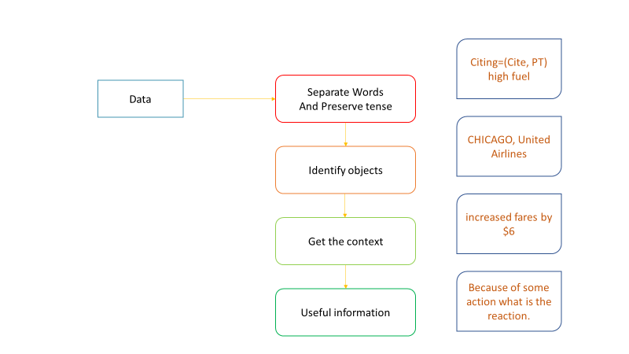

Problem Set 1 -B

Given Data:

CHICAGO (AP) — Citing high fuel prices, United Airlines said Friday it has increased fares by $6 per round trip on flights to some cities also served by lower-cost carriers. American Airlines, a unit AMR, immediately matched the move, spokesman Tim Wagner said. United, a unit of UAL, said the increase took effect Thursday night and applies to most routes where it competes against discount carriers, such as Chicago to Dallas and Atlanta and Denver to San Francisco, Los Angeles and New York

Ans

1.a Sentence Detection:

S1: CHICAGO (AP) — Citing high fuel prices, United Airlines said Friday it has increased fares by $6 per round trip on flights to some cities also served by lower-cost carriers.

S2: American Airlines, a unit AMR, immediately matched the move, spokesman Tim Wagner said. United, a unit of UAL, said the increase took effect Thursday night and applies to most routes where it competes against discount carriers, such as Chicago to Dallas and Atlanta and Denver to San Francisco, Los Angeles and New York.

b. Lemmatization

CHICAGO ( AP ) — Citing high fuel price , United Airlines say Friday it have increase fare by $ 6 per round trip on flight to some city also serve by lower-cost carrier . American Airlines , a unit AMR , immediately match the move , spokesman Tim Wagner say . United , a unit of UAL , say the increase take effect Thursday night and applies to most route where it compete against discount carrier , such a Chicago to Dallas and Atlanta and Denver to San Francisco , Los Angeles and New York

CHICAGO/NNP -LRB-/-LRB- AP/NNP Citing/VBG high/JJ fuel/NN price/NN United/NNP Airlines/NNPS say/VBP Friday/NNP it/PRP have/VBP increase/NN fare/VB by/IN 6/CD per/IN round/NN trip/NN on/IN flight/NN to/TO some/DT city/NN also/RB serve/VB by/IN lower-cost/JJ carrier/NN American/NNP Airlines/NNPS a/DT unit/NN AMR/NNP immediately/RB match/VBP the/DT move/NN spokesman/NN Tim/NNP Wagner/NNP say/VBP United/NNP a/DT unit/NN of/IN UAL/NNP say/VBP the/DT increase/NN take/VB effect/NN Thursday/NNP night/NN and/CC applies/VBZ to/TO most/JJS route/NN where/WRB it/PRP compete/VBP against/IN discount/NN carrier/NN such/JJ a/DT Chicago/NNP to/TO Dallas/NNP and/CC Atlanta/NNP and/CC Denver/NNP to/TO San/NNP Francisco/NNP Los/NNP Angeles/NNP and/CC New/NNP York/NNP

Name Entity Recognition:

CHICAGO (AP) — Citing high fuel prices, United Airlines said Friday it has increased fares by $6 per round trip on flights to some cities also served by lower-cost carriers. American Airlines, a unit AMR, immediately matched the move, spokesman Tim Wagner said. United, a unit of UAL, said the increase took effect Thursday night and applies to most routes where it competes against discount carriers, such as Chicago to Dallas and Atlanta and Denver to San Francisco, Los Angeles and New York

Potential tags:

  ORGANIZATION  
  LOCATION  
  PERSON

Co-reference Resolution :

[ CHICAGO ] ( [ AP ] ) Citing high fuel prices , [ United Airlines ] said Friday it has increased fares by 6 per round trip on flights to [ some cities ] also served by [ lowercost carriers ] . [ American Airlines ] , [ [ a unit AMR ] ] , immediately matched the move , [ [ spokesman ] Tim Wagner ] said . [ United ] , [ a unit of [ UAL ] ] , said the increase took effect Thursday night and applies to most [ routes where ] it competes against [ discount carriers ] , such as [ Chicago ] to [ Dallas ] and [ Atlanta ] and [ Denver ] to [ San Francisco ] , [ Los Angeles ] and [ New York ]



The information will get is because high price of fuel, airlines are going to increase fares for some destination.